3d Security in Cloud Computing

Step1:
Click Process button

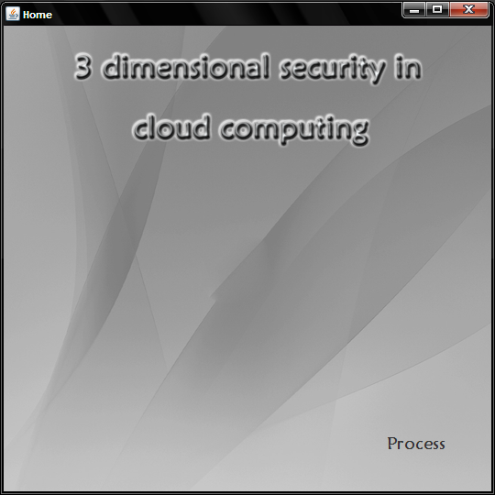

Step2:

Click Register

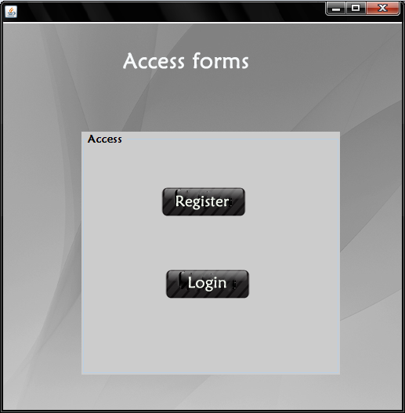

Step3:

In Registration Enter the required parameters
At last click Submit
Then Click Redirect

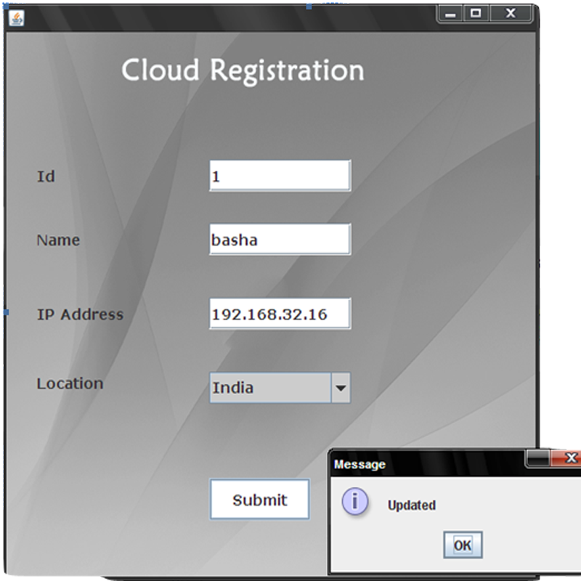

Step4:

In the prority form,

Enter the priority for CIA values

Click Submit and then Process

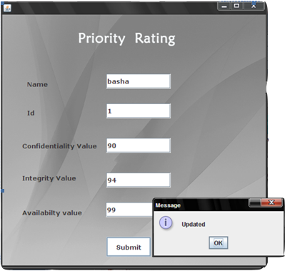

Step5:

Click Show button for Ring status and then Login

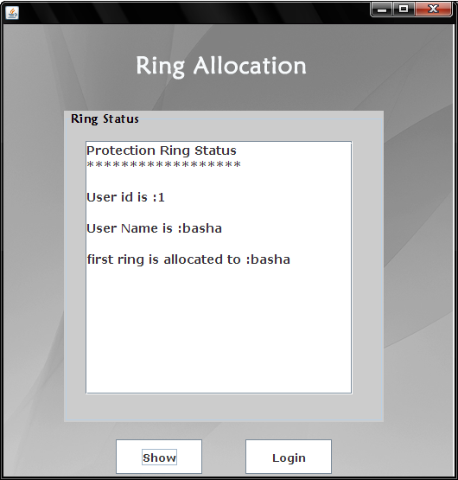

Step6:

Give Id and name for access

Click Verify and then access

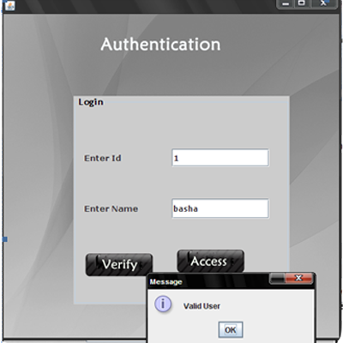

Step7:

Click Upload 2 upload the content

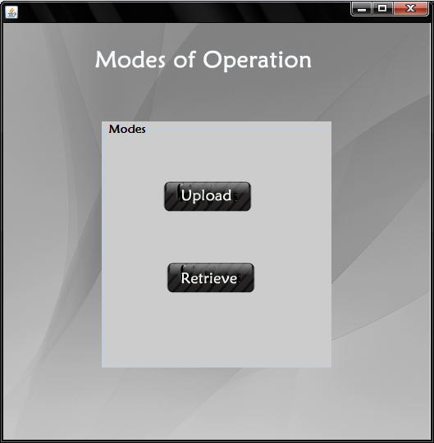

Step8:

In the template Tab

1)First select the text file by clicling apps button and then click create

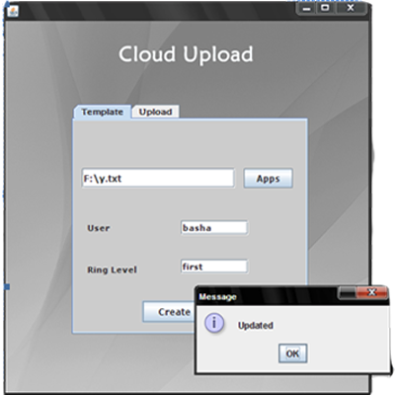

Step9:

Start the server page in Cloud server by running server.java

If localhost means run in the localsystem

Note:Don’t click any button,just run the server.java file and wait!!

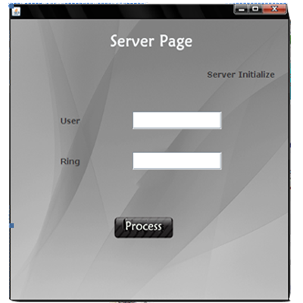

Step10:

In the client side,in the upload tab

Click request button(in upload.java file)

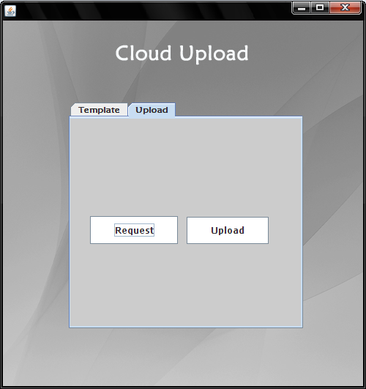

Step11:

In the server page click server initialize button

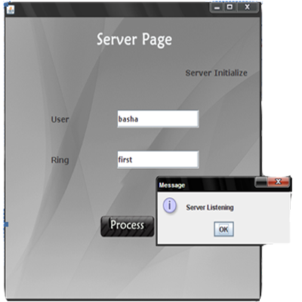

Step12:

Then Click upload button 2 upload a file

Step13:

Go to the mode.java file

Click retrieve button

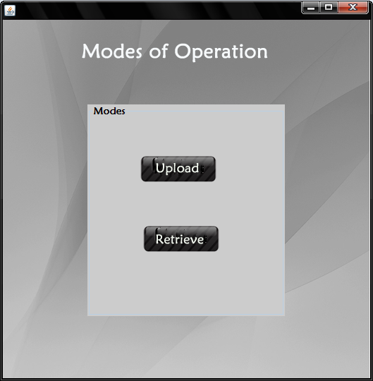

Step14:

After clicking the retrieve button retrieve request form is called automatically

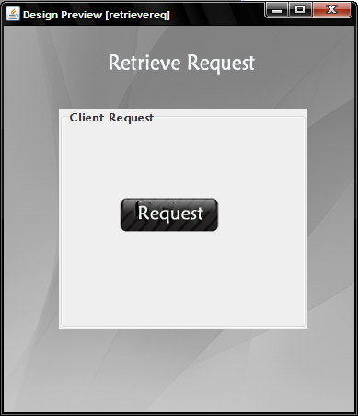

Step15:

Run user2share.java file

Click server initialize button

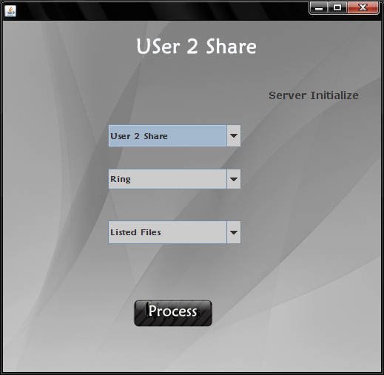

Step16:

Go to retrievereq.java and click request

Step17:

In this form select the user 2 share in the first combo box

Then select the ring level in which the files are allocated in Combobox2

Then select the file 2 retrieve in combobox3

At last click process button

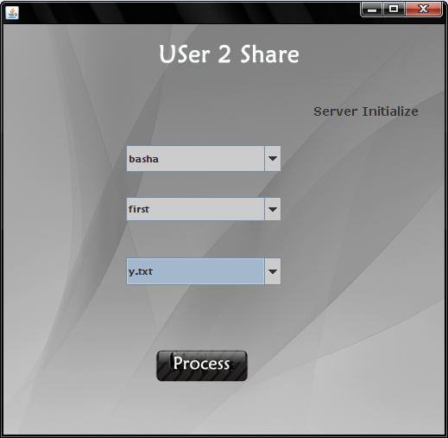

Step18:

Click verify button

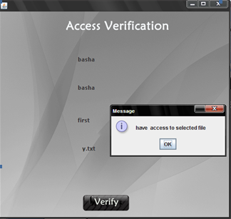

Step19:
In this form

Click retrieve and then process

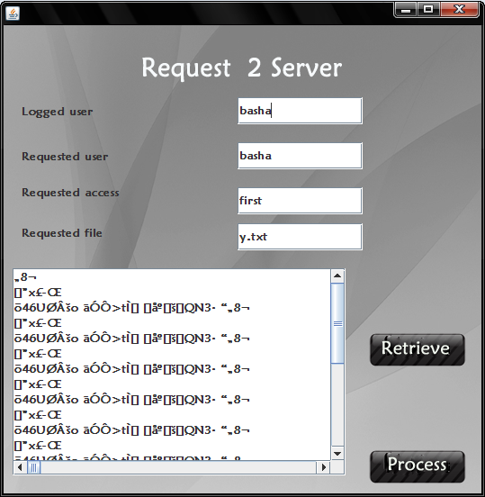

Step20:

In this form,click security check button 2 check for secured users

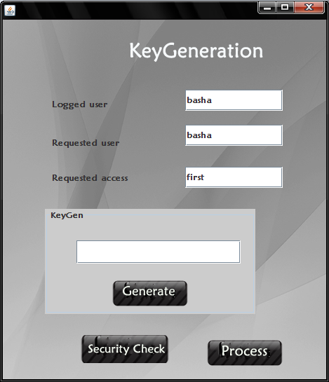

Step 21:

If secured ring User,then click generate button for the generation of private key for decrypting the given file.

Click process button

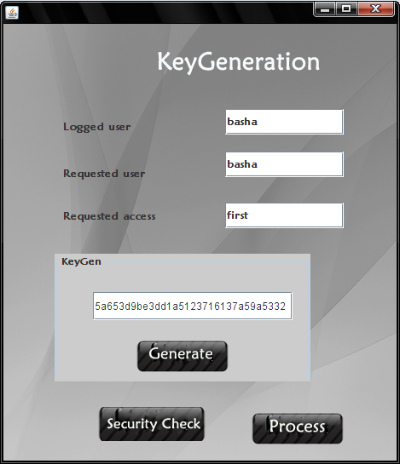

Step22:

In this form,click security check button 2 check for secured users

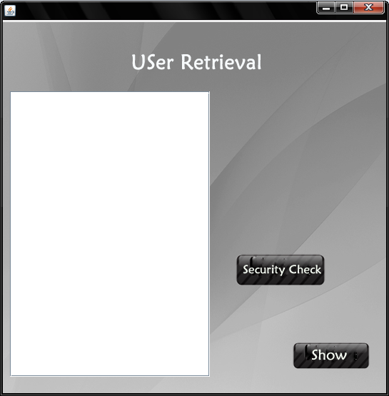
Step23:

If secured ring User,then enter the private key for decrypting the given file.

Then at last click show to view the File content.

